**DAILY ONLINE ACTIVITIES SUMMARY**

|  |  |  |  |  |  |  |  |  |
| --- | --- | --- | --- | --- | --- | --- | --- | --- |
| **Date:** | **30th may,2020** | | | | | **Name:** | **Prathusha K A** | |
| **Sem & Sec** | **4th sem &b section** | | | | | **USN:** | **4AL18CS061** | |
| **Online Test Summary** | | | | | | | | |
| **Subject** | | **1.Data communication.** | | | | | | |
| **Subject** | | **2.Complex analysis, probability and statistical methods.** | | | | | | |
| **Max. Marks** | | **1.30** | | **Score** | | | **27** | |
| **Max. Marks** | | **2.30** | | **Score** | | | **28** | |
| **Certification Course Summary** | | | | | | | | |
| **Course** | **Programming for everybody (getting started with python)** | | | | | | | |
| **Certificate Provider** | | | **Coursera** | | **Duration** | | | **7 weeks** |
| **Coding Challenges** | | | | | | | | |
| **Problem Statement: Write a c program to count uppercase, lowercase, special character and numeric values for a given string.**  I**nput :** Read a String (combination of character, numeric, special character) from keyboard. **Ex: #HaaGs01fOr@haaks07** **Output :** Upper case letters : 5 Lower case letters : 8 Numbers : 4 Special Characters : 2 | | | | | | | | |
| **Status: done** | | | | | | | | |
| **Uploaded the report in Github** | | | | | **yes** | | | |
| **If yes Repository name** | | | | | **https://github.com/prathu47/daliy_reports** | | | |
| **Uploaded the report in slack** | | | | | **yes** | | | |

Online Test Details: (Attach the snapshot and briefly write the report for the same)

1.Data communication

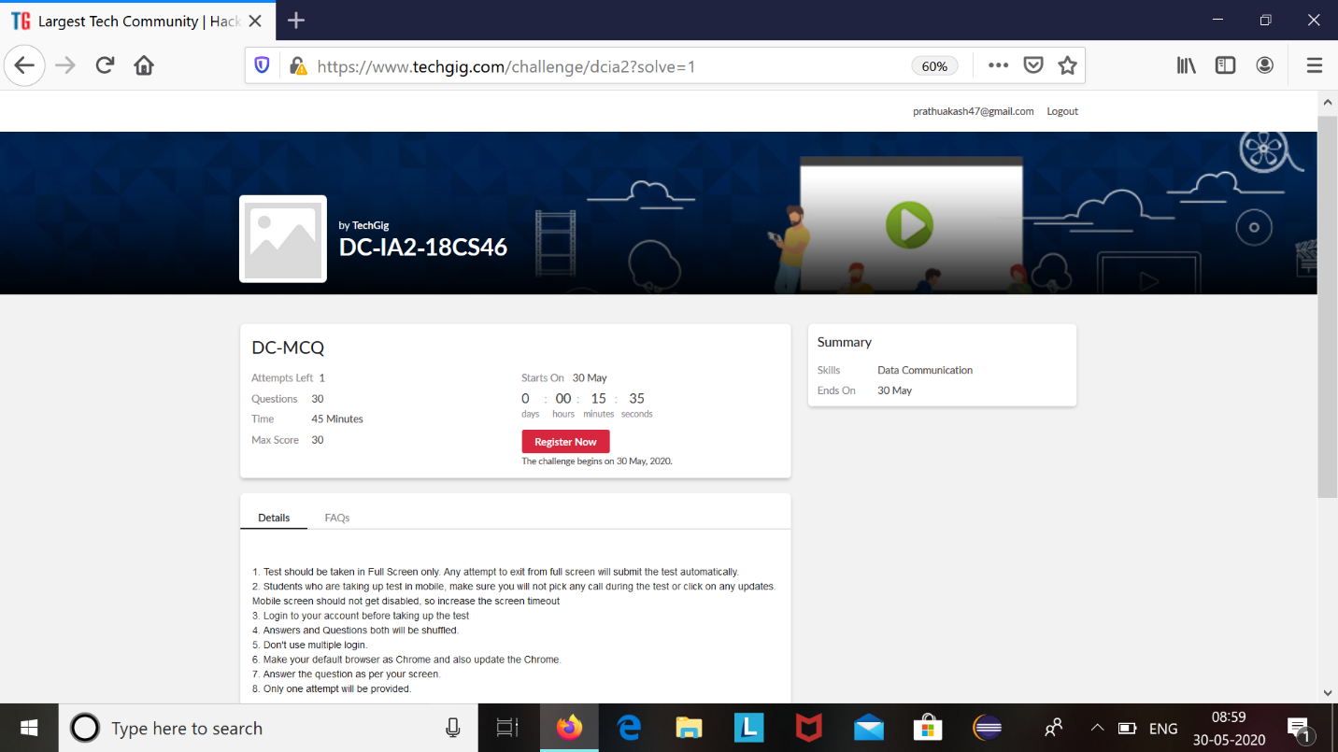

2. Complex analysis ,probability and statistical methods.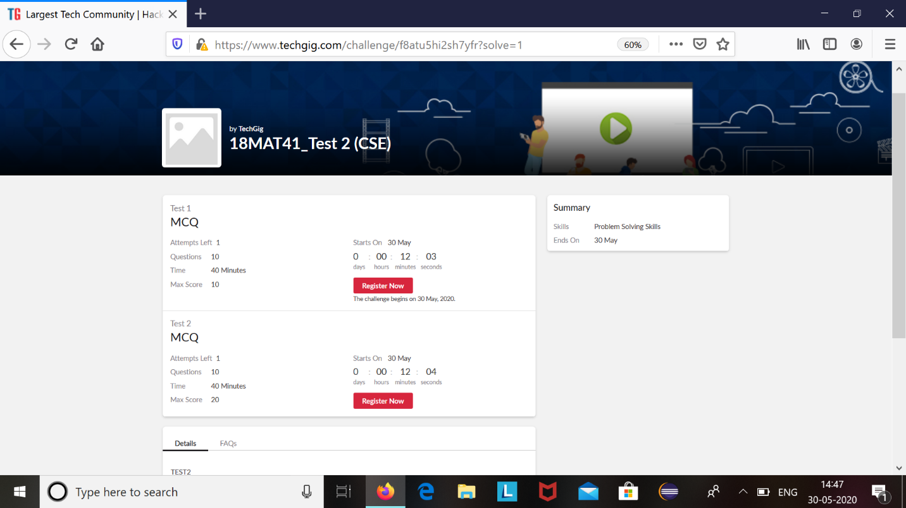

Today we had dc and mat41 internals .Dc was from 9:15 to 9:55 and Mat41 was from 3:0 to 3:40.

The above snapshot is the result sheet which was sent to us by the Techgig team.

Certification Course Details: (Attach the snapshot and briefly write the report for the same)

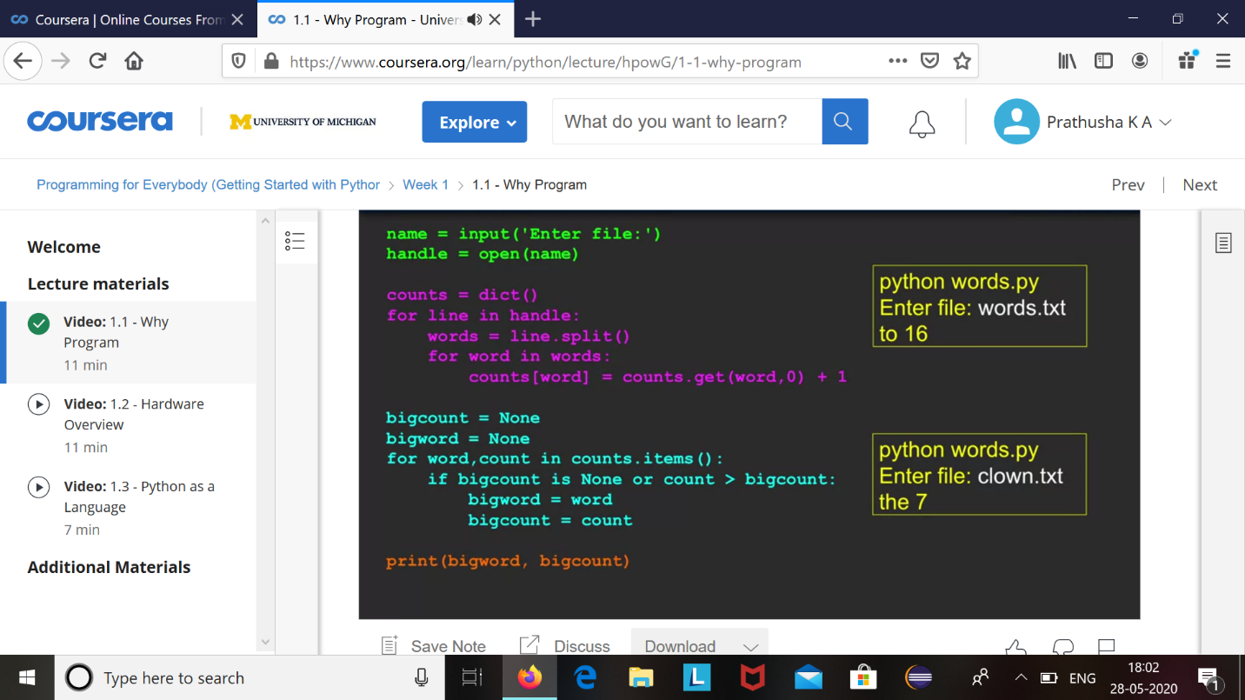

The course I have chosen during the lockdown period is programming for everybody. Since I had previously knew few topics about python iam continuing this course. (Since python is gaining a lot of interest in coding platform I have preferred to choose this course.

Coding Challenges Details: (Attach the snapshot and briefly write the report for the same)

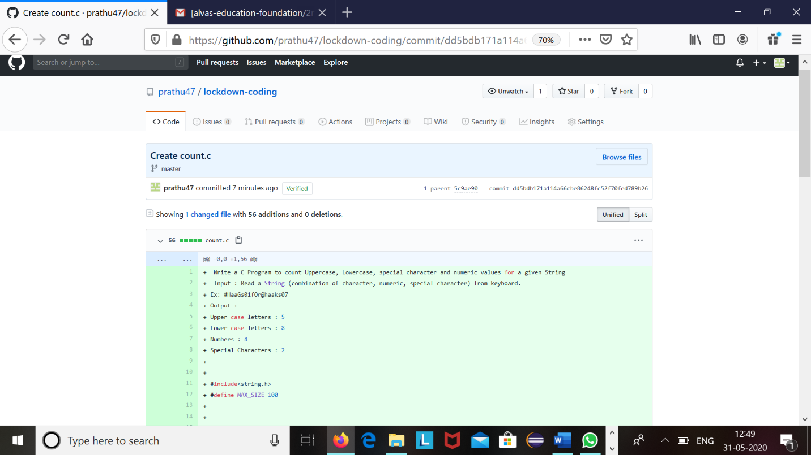

The question we had received today was :

Write a c program to count uppercase, lowercase, special characters and numeric values for a given string.

**Input :** Read a String (combination of character, numeric, special character) from keyboard.  
**Ex: #HaaGs01fOr@haaks07**  
**Output :**  
Upper case letters : 5  
Lower case letters : 8  
Numbers : 4  
Special Characters : 2

Code:The above snapshot is the code which I have uploaded in my github repository.